SETTING AWS BUDGETS

1. Go to services on the left-hand corner

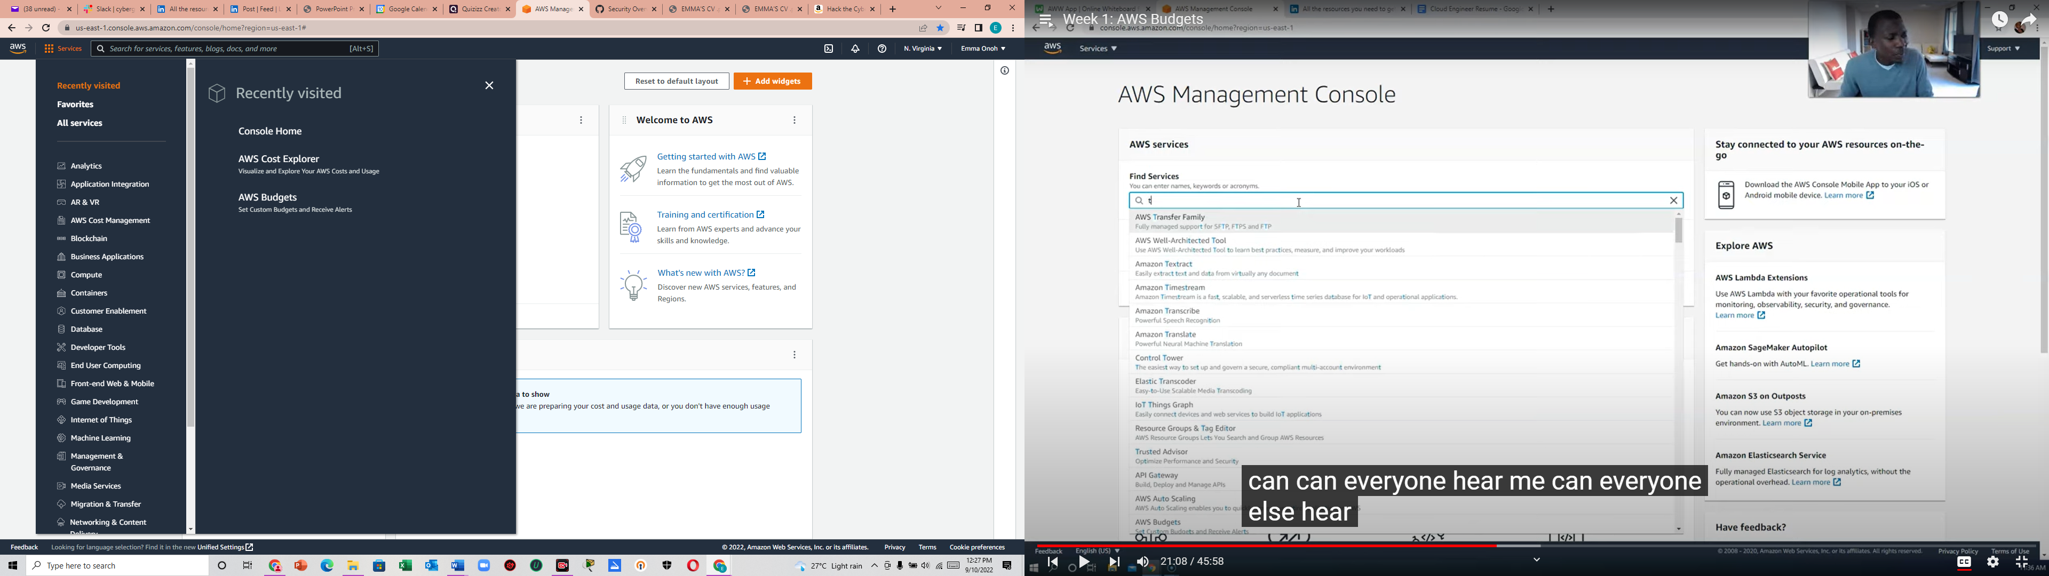

1. All Services 🡪 View All Services

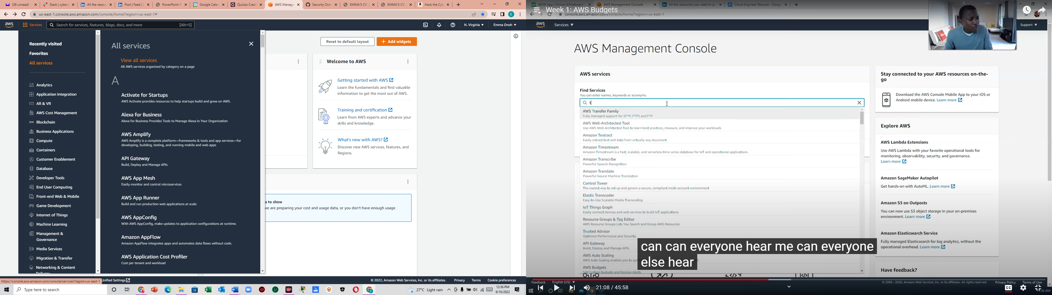

1. Click on AWS Budgets

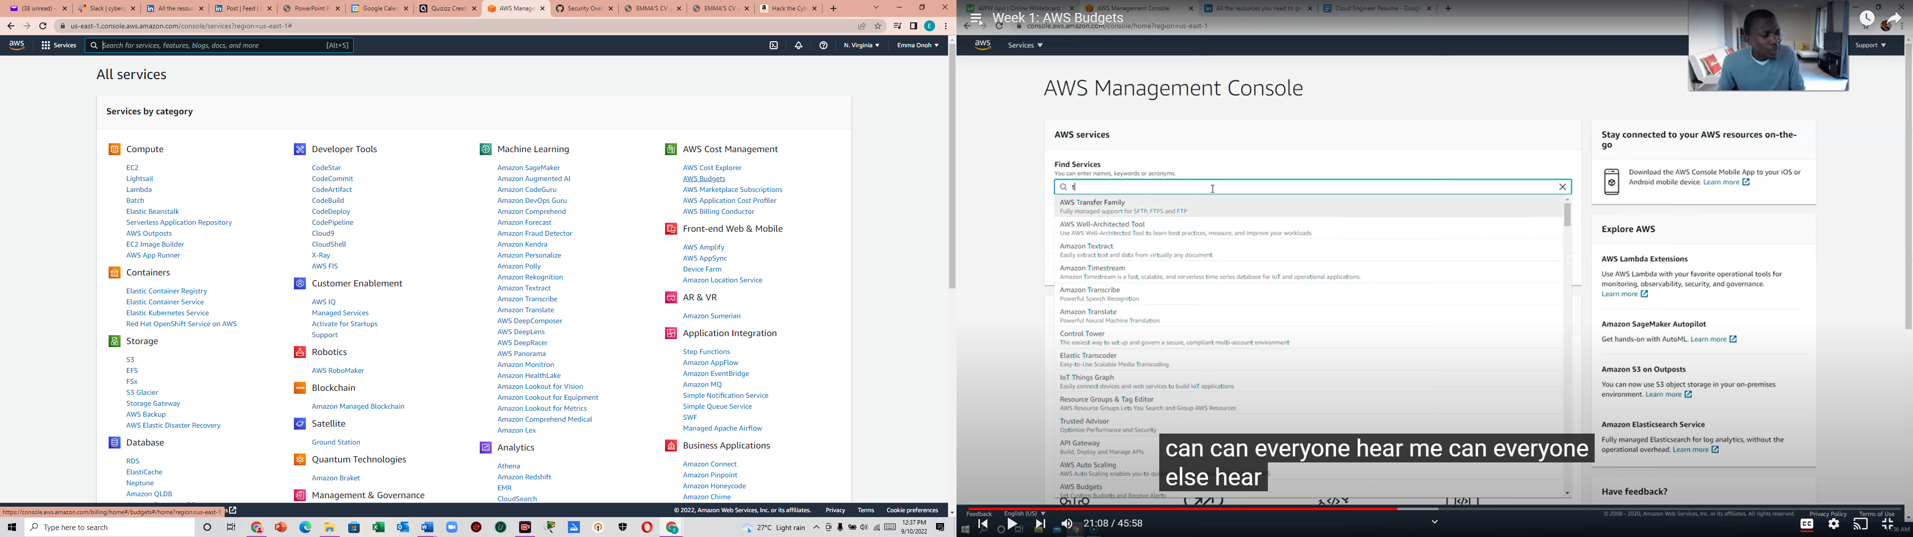

1. Click on create a budget

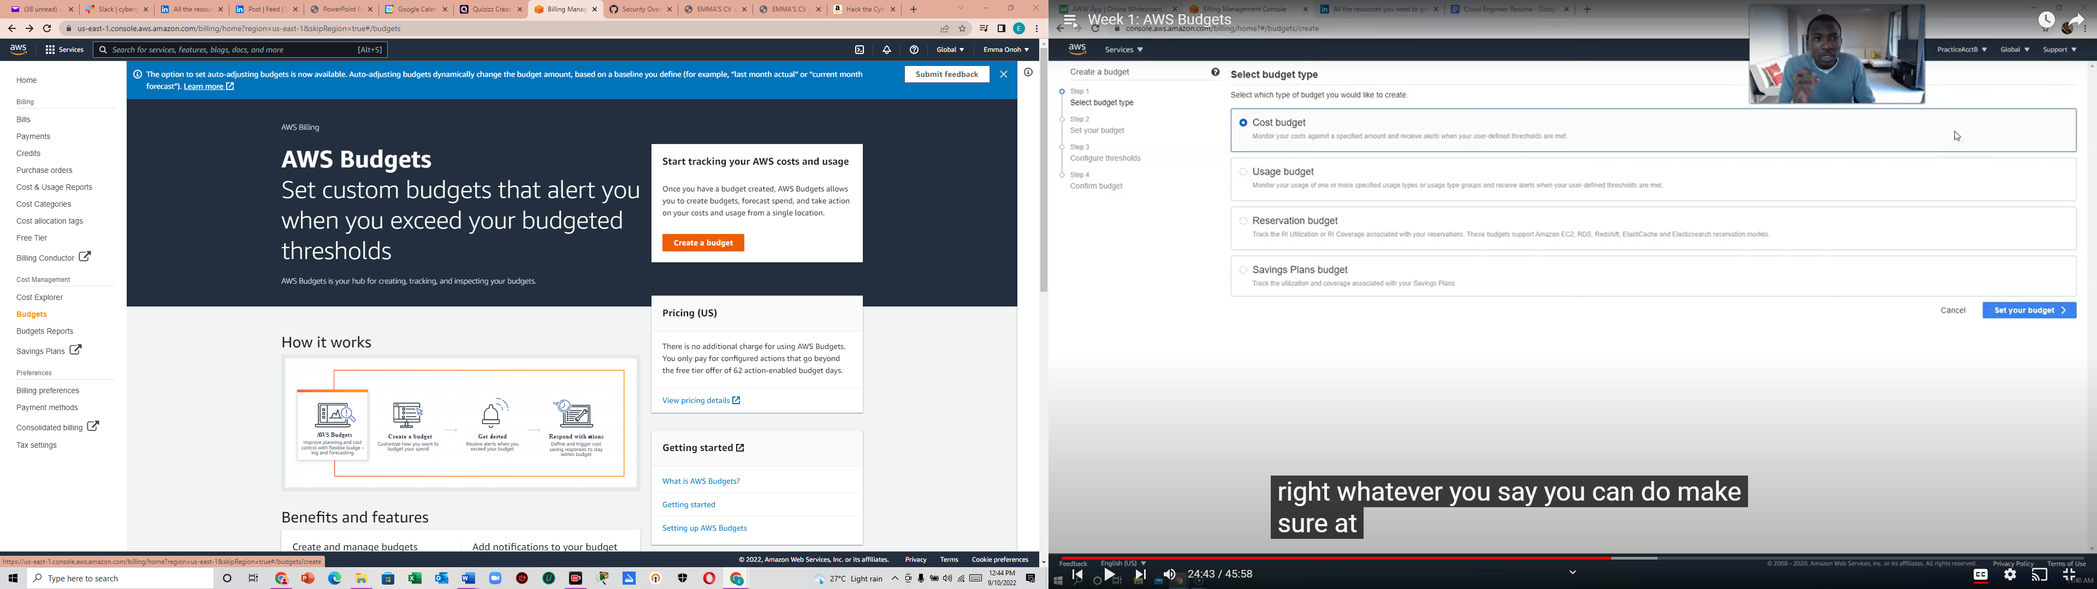

1. Choose your budget type and click Next

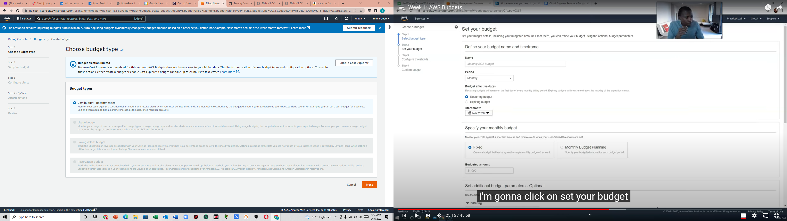

1. Fill in the details and go to the next page

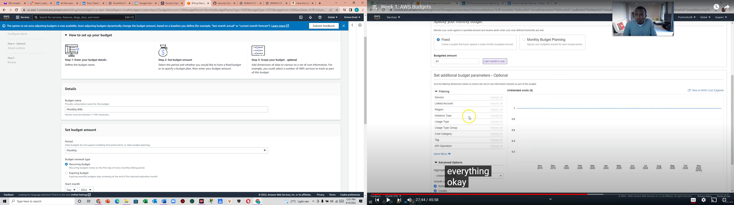

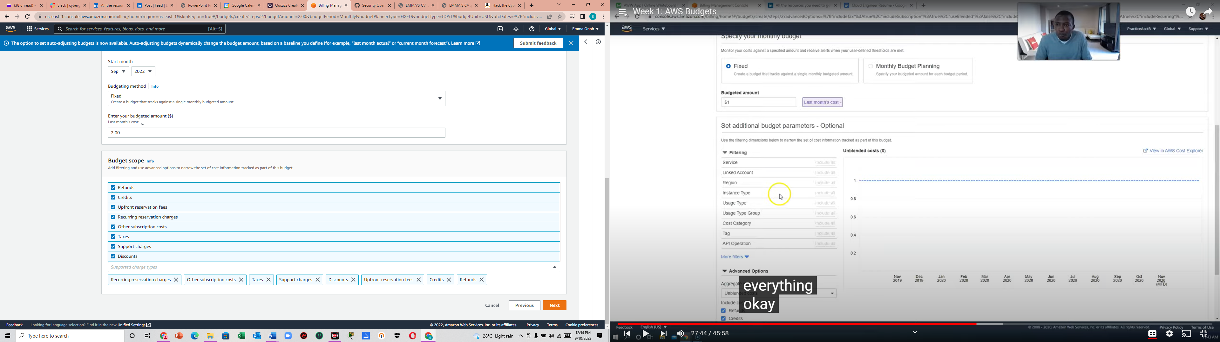

1. Configure your threshold and click Next

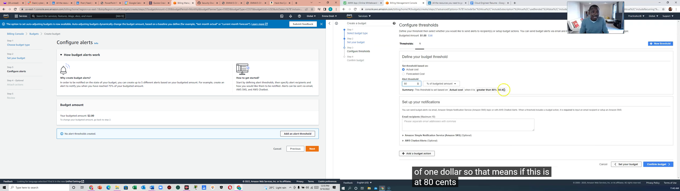

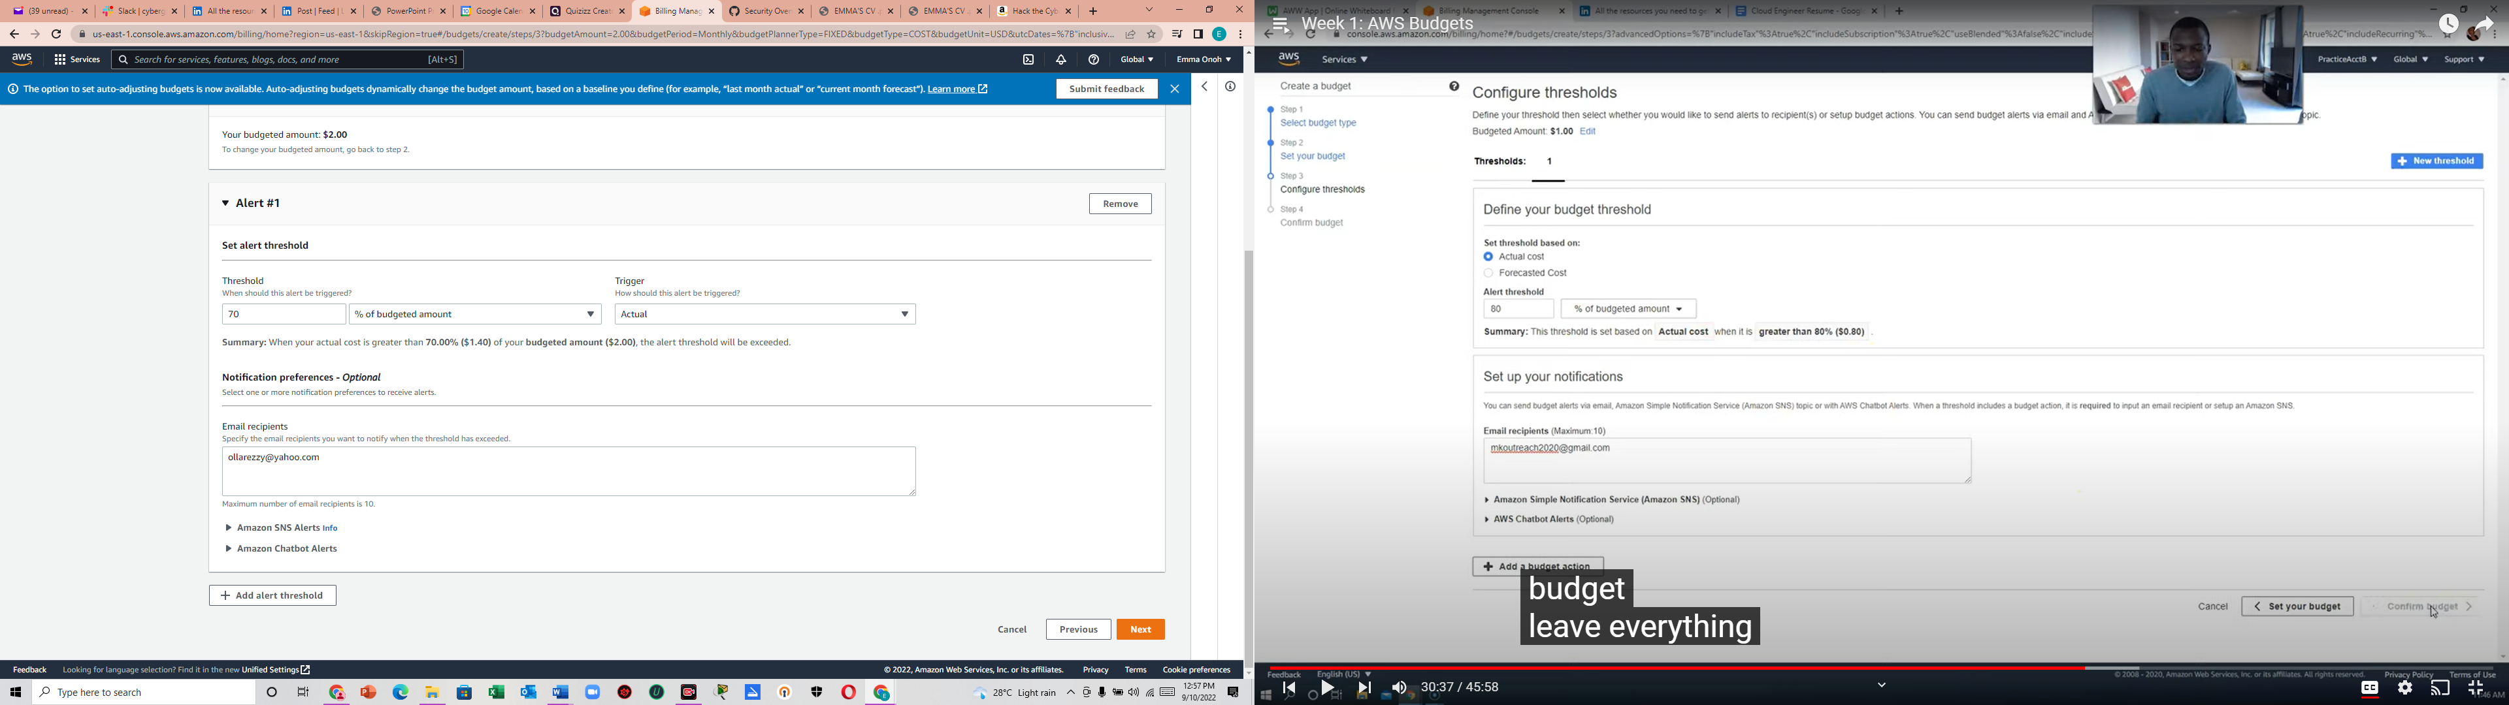

1. You may or may not attach actions. Then click Next.

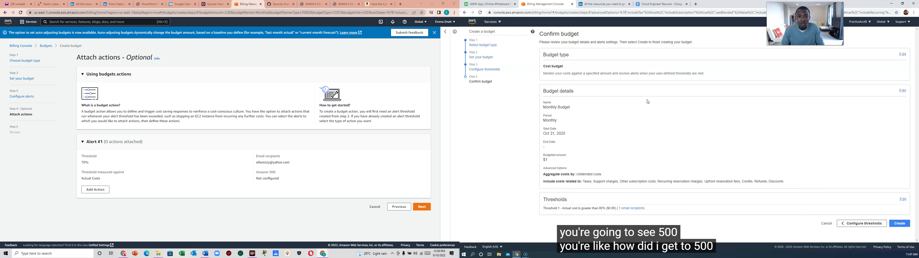

1. Review your budget and then click on Create Budget

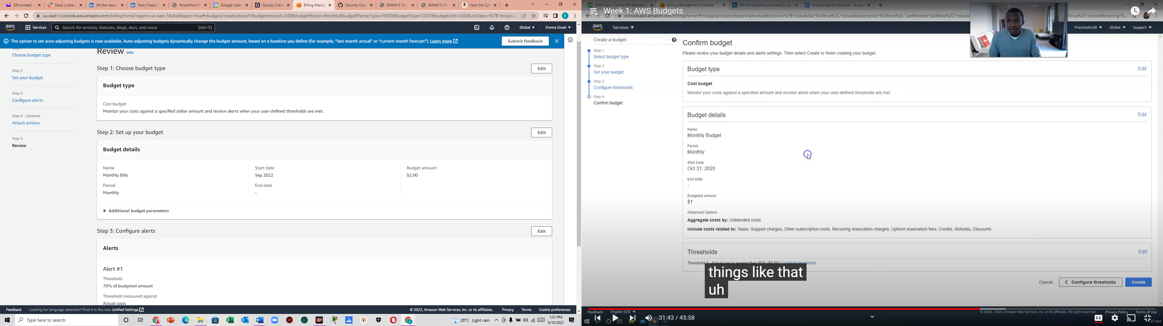

1. Success!

